**5 Ways to Project Confidence in Front of an Audience**

by

* [Carmine Gallo](https://hbr.org/search?term=carmine%20gallo)

May 28, 2018



Michael Blann/Getty Images

Summary.

You might have a great idea or results to share, but if you don’t deliver your message with confidence, it will fall on deaf ears. Here are five tips to look and sound like a leader people will want to follow. Dress 25% better than anyone else in the room. Your clothes need to be appropriate for the situation, but aim to be slightly more polished. Pace your speech. Speaking too fast will harm your credibility. Use simple words. Long, convoluted sentences and jargon don’t make you sound smart at all — just the opposite. You gain credibility and respect when you’re able to articulate complex ideas in simple language. Before an important presentation, consider gathering a few people to watch a dress rehearsal, even if it’s in your office or even your living room, rather than practicing alone in a mirror. Simulating even low levels of stress will keep you from cracking under pressure when delivering the real deal. And lastly, maintain an open posture. Don’t keep your hands in your pockets or by your side. Use hand gestures that are natural and authentic.close

Employees, investors, and partners don’t just follow anyone — they follow leaders who have command of the business and command of the stage. Whether you’re presenting on an analyst call or speaking to your entire organization in a town hall meeting, you’re being judged on your confidence and competence, not just your content, and the way you appear and how you sound matters.

[A study on CEOs](https://www.gsb.stanford.edu/insights/elizabeth-blankespoor-ipo-road-shows-messenger-message) giving IPO road-show presentations found that even hardened financial advisors judge a leader’s “competence and trustworthiness” within as little as 30-seconds. These snap judgments are so powerful, CEOs who rated the highest for their executive presence in the study enjoyed higher IPO valuations.

Here are five keys to look and sound like a leader people will want to follow whenever you’re presenting.

**Dress 25% better than anyone else in the room.**[The evidence](http://www.apa.org/gradpsych/2012/11/first-impressions.aspx) shows we size people up as soon as they walk into a room. And the first thing we often do — like it or not — is notice a person’s clothes. You’ve probably heard the advice to “dress to impress” but what exactly does that mean?

Several years ago, I had the opportunity to meet retired U.S. Army Commander Matt Eversmann, who teaches leadership at Johns Hopkins University. The battle he led in Mogadishu, Somalia, was turned into the movie *Black Hawk Down*. “Great leaders have an air of confidence,” he told me. “In the military, it all starts with how you’re dressed the first time you meet a subordinate. Always dress a little better than everyone else and you’ll look confident.” You’ll note that he said a *little* better. Your clothes need to be appropriate for the situation, but aim to be slightly more polished.

James Citrin, a leading CEO recruiter, once advised job candidates to dress 25% “more formal” than the prevailing dress code at the company. Update your wardrobe once or twice a year, wear clothes that fit your body type, choose colors that compliment your skin or hair color, and avoid worn or scuffed shoes.

**Pace your delivery.**We can’t do much about our vocal quality without extensive singing lessons to control our breathing and pitch. We can, however, improve our vocal delivery, specifically, pace. I provide the narration for my own audiobooks and the first time I walked into a studio and began reading, an audio producer told me to slow down. The ideal pace for an audiobook is a little slower than casual face-to-face conversation because listeners don’t have the added sensory inputs of watching your mouth move and facial expressions. This is about 150 words a minute. While you may not be recording an audiobook, the same rule applies when you’re giving a webinar or online presentation where your audience only hears your voice. Speaking too fast will harm your credibility.

If you are talking live with your group, you can go at a slightly faster pace since that is more natural for face-to-face conversations, but still be careful not to rush.

A speaker with great verbal pacing is [Bryan Stevenson](https://www.ted.com/talks/bryan_stevenson_we_need_to_talk_about_an_injustice), a human rights attorney who received the longest standing ovation ever given at a TED talk. When I asked Stevenson about his speaking style, he told me that he imagines he’s talking to a friend over dinner in a restaurant. Stevenson’s TED talk is 190-words a minute — *slightly* faster than an audiobook, but not as fast as a rapid-fire motivational speaker who might clock in at 220 words a minute.

**Replace long words with short ones.**If you want to sound smart, use simple words. Long, convoluted sentences and jargon don’t make you sound smart at all — just the opposite. In his book, *[Thinking, Fast and Slow](https://www.amazon.com/dp/B00555X8OA)*, Nobel prize-winning psychologist Daniel Kahneman writes, “If you care about being thought credible and intelligent, do not use complex language where simpler language will do.”

**YOU AND YOUR TEAM SERIES**

**Public Speaking**

* 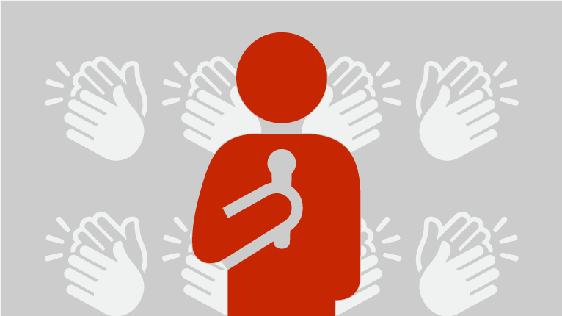

[**How to Stop Saying “Um,” “Ah,” and “You Know”**](https://hbr.org/2018/08/how-to-stop-saying-um-ah-and-you-know)

* + Noah Zandan

[**How to Calm Your Nerves Before a Big Presentation**](https://hbr.org/2016/10/how-to-calm-your-nerves-before-a-big-presentation)

* + Amy Jen Su

[**5 Ways to Project Confidence in Front of an Audience**](https://hbr.org/2018/05/5-ways-to-project-confidence-in-front-of-an-audience)

* + Carmine Gallo

Using simple words doesn’t imply dumbing down your message. You gain credibility and respect when you’re able to articulate complex ideas in simple language. Recently, I spoke to the co-founder of a tech company, Collective Health, that provides health-insurance plans for major corporations. He told me that because surveys show that most people do not have a sophisticated understanding of insurance terms, the company aims to write its material in language that a third-grader can read and understand. Communicating in accessible language makes it less likely that customers will choose the wrong plan.

**Rehearse under stress.**Neuroscientists who study high-performing athletes and professionals have found that the most successful [practice under mild stress](https://health.usnews.com/health-news/family-health/brain-and-behavior/articles/2010/09/21/trouble-coping-with-stress-under-pressure-train-your-brain). In other words, they rehearse under similar conditions they’re likely to encounter during the actual event. Before an important presentation, consider gathering a few people to watch a dress rehearsal, even if it’s in your office or even your living room, rather than practicing alone in a mirror. Simulating even low levels of stress will keep you from cracking under pressure when delivering the real deal.

**Maintain an open posture.**[Studies](https://goldin-meadow-lab.uchicago.edu/sites/goldin-meadow-lab.uchicago.edu/files/uploads/PDFs/2015_Novack_GM.pdf) have shown that complex thinkers use complex hand gestures. Don’t keep your hands in your pockets or by your side. Use hand gestures that are natural and authentic. One tip is what body language experts call “open posture.” Having two hands, palms facing up, above the waist would be considered open. A closed posture would be two hands clasped in front of your waist or arms folded across your chest. Standing behind a podium is also considered closed because you are placing a barrier between you and your audience. Demonstrate confidence showing you have the courage to step away from the lectern (and your notes) and work the room.

You might have a great idea or results to share, but if you don’t deliver your message with confidence, it will fall on deaf ears. Look and sound as strong as your content and you’ll find a receptive audience.